**COMPUTER GRAPHICS ASSIGNMENT 3 REPORT**

**Georgiadis Nikolaos**

**Task 2**

The moon can be observed in the left side of earth as a white point:

**Task 3**

After a small amount of rotation of all objects to the right:

**Task 4**

After some rotation of objects around their respective y-axis and rotation of earth and moon around sun and earth respectively:

**Task 5**

We implemented a hierarchical model which includes one textured pyramid and two fixed color spheres. The big sphere is responsible for the illumination. The total movements/relationships of the objects are the following:

* Pyramid makes a periodic move, left and right(x-axis) with Amplitude = 2:

x(t) = 2sin(t)

* The big illumination sphere has 25% the size of pyramid and rotates around it(z-axis rotation). It is translated by dx=-5 and dz=3 from the position of the pyramid. As pyramid moves left and right, the sphere follows the same moves + rotating around pyramid.
* The small sphere has 25% the size of the big sphere and rotates around it(z-axis rotation). It is translated by dx=7 from the position of the big sphere. As big sphere is moving around(following pyramid’s movements), the small sphere follows the same movement while rotating around pyramid

We can form the tree of hierarchy like following:

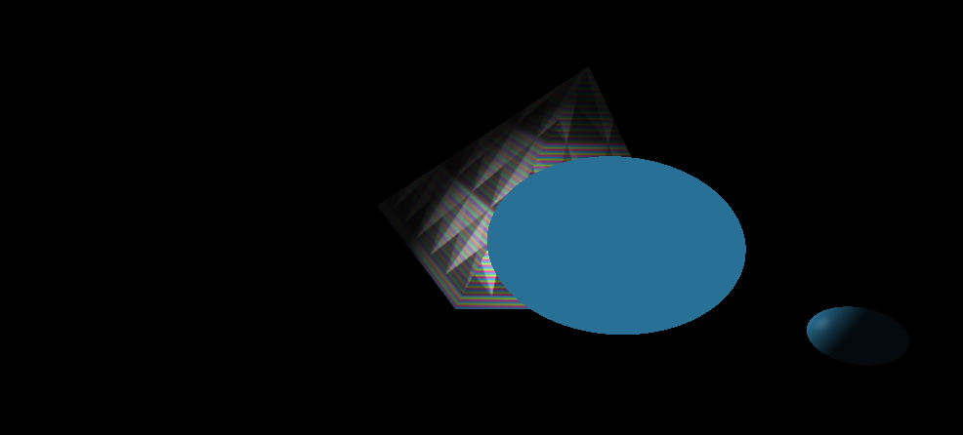

Source for pyramid vertices/uv coordinates:

[**https://stackoverflow.com/questions/66879250/texture-mapping-a-pyramid**](https://stackoverflow.com/questions/66879250/texture-mapping-a-pyramid)